# 3NF Relational Model

## 1NF:

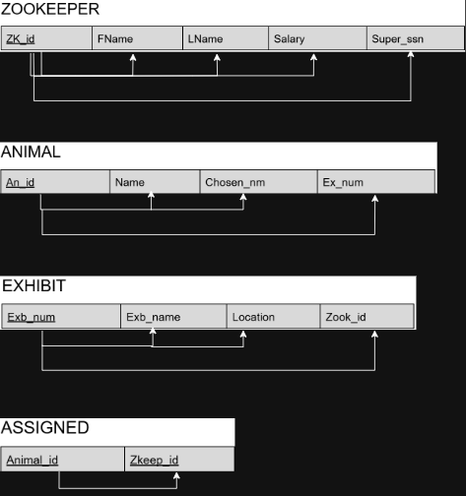

***NOTE FOR GRADER: “Super_ssn” in ZOOKEEPER is meant to be “Super_id”, Thank you!***

## 3NF:

### Z1

### Z2

## FOR GRADER: Super_ssn should be Super_id, Thank you!

### A1

### A2

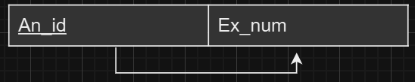

### EX1

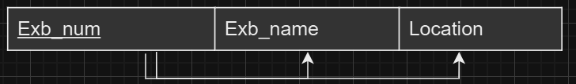

### EX2

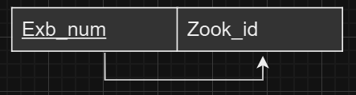

### ASSIGNED

